Traffic Engineering

Group Member’s Name
Instructor’s Name
Course
Institution Affiliation
Date

Contents
Executive summary 3
Introduction 4
Results. 4
Discussion of graphs. 5
Conclusion. 7
References 8

Executive Summary
Understanding the relationship between flow, density, and space means proved to be of great significance around the globe. May agencies have tried to link the relationship in order to aid in the control of roads for a long time. And luckily, they are moving closer and closer to understanding the relationships and also among other factors
This lab project aims to establish a relationship among flow, density, and space mean speed using the data collected at large from a narrower perspective linking the results to the study objectives. The primary data is obtained from the Regional Integrated Transportation Information System from which graphs were drawn to make conclusions.

Introduction
This lab project gives detailed information on the objective of the study. After collecting data, different graphs were drawn, including a plot of flow vs. density, flow vs. speed, and density vs. speed. The plots try to establish a certain relationship between the flow, density, speed, and space mean speed, which will be discussed extensively in the report. Before making the plots, it is assumed that from detectors, as the density increases, the flow will increase up to a certain point when it starts to decrease. The point is the critical density. Also, as the flow increase, there is a decrease in speeds. This is because of the jam density on the road. It is also assumed that there is a linear decline in speed as the density increases.
The project will focus on two different types of data, and it will consider and describe as possible the relationship between flow, density, and speed. It will consider the number of lanes and how it affects the capacity.

Results
FLD4095SB031.B
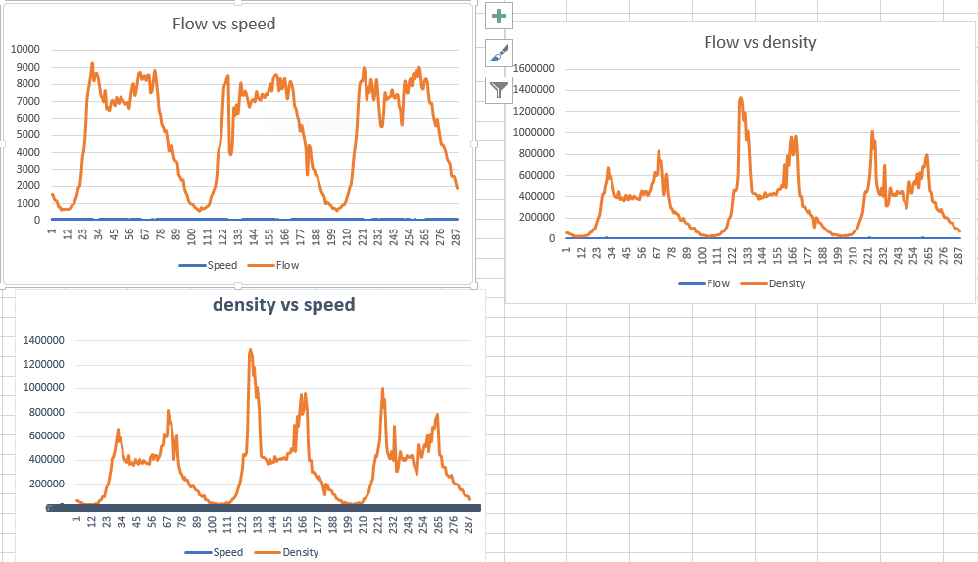

DS-033S-GB
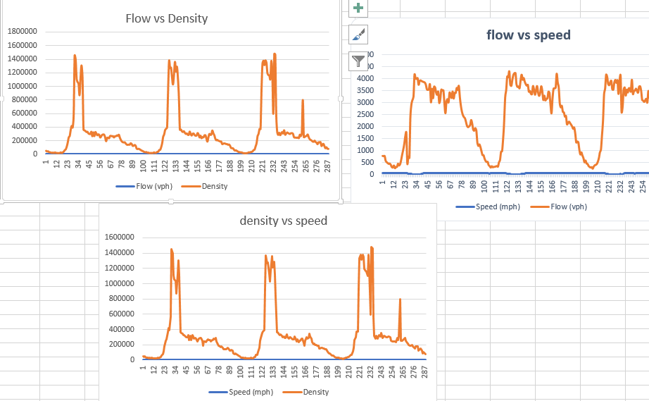

Discussion of Graphs
From the graphs above, in the first detector; the flow vs. speed is as shown; it was noted that the flow increases as the speed increase, up to a certain point, and from our data, the critical speed was 30 mph, which is the point at which it will start to decelerate again. Also, the curve of density vs. speed, it was observed that an increase in density resulted in a decrease in speed. The flow vs. density curve indicated a situation where it was observed that an increase in flow resulted in an increase in density in the lane.
Hence from the curves
The critical density per lane=1323813.33
The jam density=58226.6667
The free flow speed= 56 mph
The capacity per lane=$N=1760\frac{V}{L}=1760×\frac{56}{5}$ =19712.

Detector DS-033S-GP
From the curves above, a flow increase leads to a decrease in speed. For the density vs. speed, it increases sharply, and upon reaching the optimum point, it starts to decrease. Also, the density increases lead to a decrease in speed.
Hence from the curves
The critical density per lane=139645.89
The jam density=68046.51
The free flow speed= 63 mph
The capacity per lane=$N=1760\frac{V}{L}=1760×\frac{63}{3}$ =36,960.
From the analysis above, we can conclude that the data provided gives out the expected curves; hence data provided proved to be valid.

Conclusion
As analyzed from the curves, it is observed that there was a relationship between the quantities. The flow was independent of other variables, including the speed; it was observed that the more the number of lanes are, the higher the capacity and higher free-flow speed.
The method and data we obtained for our study were sufficient enough to meet our objective of establishing a relationship between flow, density, and speed. It’s understood that data collection tools are continually improved in order to give a vivid analysis with time.

References
Akyildiz, I. F., Lee, A., Wang, P., Luo, M., & Chou, W. (2016). Research challenges for traffic engineering in software-defined networks. IEEE Network, 30(3), 52-58.
Mendiola, A., Astorga, J., Jacob, E., & Higuero, M. (2016). A survey on the contributions of software-defined networking to traffic engineering. IEEE Communications Surveys & Tutorials, 19(2), 918-953.
Shu, Z., Wan, J., Lin, J., Wang, S., Li, D., Rho, S., & Yang, C. (2016). Traffic engineering in software-defined networking: Measurement and management. IEEE Access, 4, 3246-3256.

